Request for Proposal (RFP)

Provisioning and Resale of IP Transit Bandwidth to an <CDN> Cache

RFP Reference #: UIXP/RFP/2017/001
Issue Date: February 1, 2017
Bidders’ Meeting: February 20, 2017 (14:00)
Submission Deadline: March 2, 2017

- Statement of Purpose
The Uganda Internet eXchange Point (UIXP) is seeking to enter into a six (6) month renewable contractual agreement with an Internet Service Provider (ISP) which agrees to provision IP transit bandwidth capacity to an <CDN> cache (CDN) and re-sell access to other networks via the UIXP switching infrastructure.

- Questions About the Request For Proposal
All questions pertaining to this RFP will be answered at the Bidders’ Meeting and must be submitted prior to that date. No answers will be provided and/or circulated prior to that date. No interpretation of the meaning of these documents will be made to any bidder prior to the Bidders’ Meeting.
Questions may be submitted, in written form to: uixp-admins@googlegroups.com

- Submission Procedure
  - All proposals must be received in hard-copy at the following address no later than the Submission Deadline:
Uganda Internet eXchange Point
c/o Kasirye Byaruhanga & Co, Advocates
Plot 33, Clement Hill Road
Kampala, Uganda
In addition to the hard-copy, soft-copies can be submitted in PDF format to the following e-mail address: uixp-admins@googlegroups.com
  - Proposals must state that they are valid for a period of at least 60 days from the Submission Deadline.
  - Physical proposals must be submitted in a sealed opaque envelope or container marked with the RFP Reference # and the name and address of the bidder.
  - UIXP management reserves the right to waive irregularities and to reject any or all bids.
  - Any bid may be withdrawn prior to the Submissions Deadline or authorized postponement thereof.
  - Proposals should include the following information:
    - Cover letter
    - Company Description
    - Autonomous System Number (ASN)
    - Estimated Internet customer base
    - List of any IP transit customers
    - List of upstream IP transit links (including backups) and the current capacity on each
    - List of any relevant PNIs or peering links with the CDN’s network
    - Other relevant details as per the Selection Criteria (see below)
- Bidders’ Meeting
There will be an opportunity for prospective bidders to meet with UIXP management for a Question and Answer (Q&A) session on the Bidders’ Meeting date/time (see above) at the following location:
Hive Colab
Kanjokya House, 4th Floor, Suite 404
90 Kanjokya Street
Kampala, Uganda
Participation at the Bidders’ Meeting is not mandatory; however, it is limited to two (2) people per firm/organization. If you are intending to send representatives to this meeting, please submit their names and titles to:
uixp-admins@googlegroups.com
Following the meeting, UIXP management will create a meeting record that will be distributed to Bidders after two (2) working days. These minutes will serve as the official record of the items discussed and resolutions made during the meeting. Any and all modifications noted in these minutes will be shared with all bidders.
- Modification of Proposals
Modifications to bids already submitted will only be allowed if submitted in writing prior to the Submissions Deadline.
- The Business / Operating Model
The Selected ISP will provide IP transit bandwidth capacity to the the CDN and subsequently resell access to the CDN to other participant networks at the UIXP in order to repay the costs incurred for providing the IP transit bandwidth capacity. The following table outlines the contractual relationships exclusive to this project:
 | UIXP | Other networks
CDN | Contractual agreement related to hosting the CDN at the UIXP facility. | N/A
Selected ISP | Non-financial contractual agreement for the provisioning of IP transit bandwidth to the CDN, redistribution of CDN content, and to be a UIXP peer network. | Financial contractual agreement for the provisioning/redistribution of CDN content.
Other networks | N/A | N/A

Note: The UIXP shall NOT pay the Selected ISP for the IP transit bandwidth capacity or any other costs, fees, or charges associated with this agreement.

- Scope of Work
  - The Selected ISP shall perform the following service for the contract period:
    - Provide IP transit bandwidth capacity to the CDN located in the UIXP facility. The cost of providing this IP transit will be recovered by the Selected ISP at a published rate of Cu as per Section 7ii (see below).
The UIXP facility is physically located at:
Communications House
1 Colville Street
Kampala, Uganda

    - Enable other networks to access the CDN strictly through the UIXP switching platform, measure their utilization, and bill them monthly using the following formula:
(O/T) * B * Cu
      - O = Traffic from the cache out to a network (Mbps)
      - T = Total traffic from the cache out to all networks (Mbps)
      - B = Peak cache-fill bandwidth in to the cache in the month (Mbps)
      - Cu = Resale cost (per Mbps in USD) of cache-fill bandwidth excluding VAT
    - Provide a monthly consumption report to the UIXP and all other networks connected to the UIXP which consume CDN content. This report should include the Selected ISP’s own consumption level, if any.
  - The UIXP will provide the Selected ISP and other networks:
    - Rackspace, power, and other accommodations according to UIXP policy.
    - Access to an independent measurement system that tracks utilization of the cache on an aggregate basis.
    - Access to a CDN provided measurement panel, if any, which provides statistics on cache utilization and efficiency.

- Diagram of Network Topology and Business Model
The following diagram illustrates the general network topology and business model for this project. The final arrangement may vary:
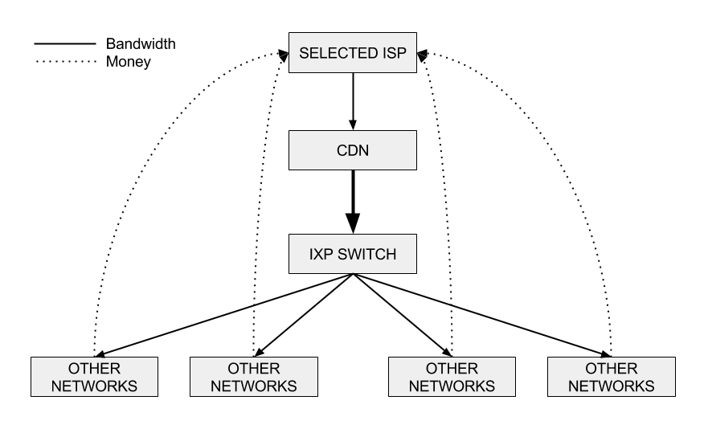

- Selection Criteria
The following criteria will be used to select the winning bidder:
  - Total IP transit bandwidth capacity able to be committed and/or allocated to the CDN. This should be communicated in peak megabits per second (Mbps).
  - Technical ability to deliver the transit including any redundancy mechanisms that help to ensure quality and reliability of the service.

  - The proposed selling price of one (1) megabit per second (Mbps) of CDN cache content. This price represents the variable Cu in the billing formula stipulated in Section 7b of this document. This price should be tax exclusive and should be expressed in United States Dollars (USD).

